**Nov 2014 HL P1**

**Section A**

1. State **one** example of application software. [1]
2. Identify **two** methods that can be used to prevent data loss. [2]
3. Identify **two** methods of providing user documentation. [2]
4. Outline the need for higher level languages. [2]
5. State **one** function of the operating system in managing memory. [1]
6. Construct a logic diagram for the Boolean expression

A and B or not B. [3]

1. Define the term recursion. [1]
2. 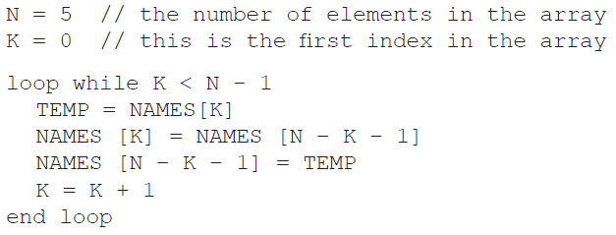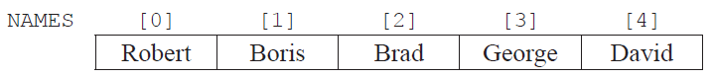Consider the following array  
     
     
     
     
   and the following algorithm, which is constructed to reverse the contents of the array NAMES.
3. Trace the algorithm, showing the contents of the array after each execution of the loop. [2]
4. Identify the type of error that occurs. [1]
5. Outline why the error occurs and how it could be corrected. [2]
6. (a) Outline the differences between a LAN and a VLAN. [3]

(b) Identify **two** factors that should be considered when selecting transmission media. [2]

1. 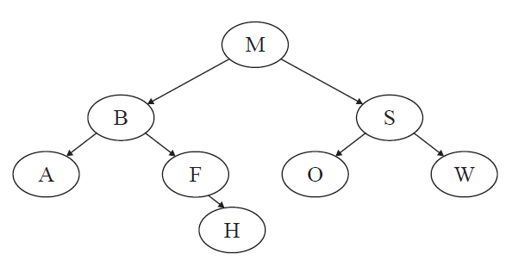Consider the following binary search tree.
2. State the order in which data will be listed using preorder traversal. [1]
3. State the number of leaf nodes in the tree. [1]
4. Construct the tree after adding the node L. [1]

**Section B**

1. The temperature (in °C) of a lake was recorded every hour, every day, for one week. As each reading was taken, it was added sequentially to the collection TEMPERATURES, which is stored permanently.

At the end of the week this data was read into a two-dimensional array named TEMPWEEK as shown below.

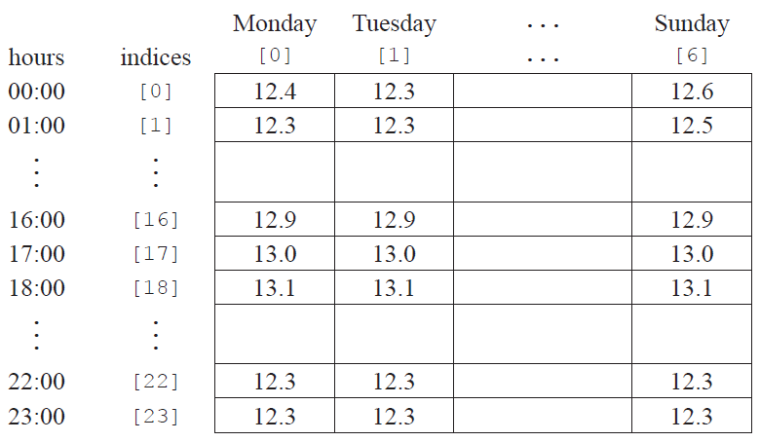

1. Construct the algorithm that will read the data from the collection into the array. You can use the   
   collection functions TEMPERATURES.getNext() and TEMPERATURES.isEmpty(). [5]
2. Using the array TEMPWEEK, construct an algorithm to determine and output the minimum   
   temperature for the week. [4]
3. If the temperature is less than 12.0°C then the day, time and temperature are also placed in  
   a separate data structure.
4. Describe a dynamic data structure that might be used to hold this data. You may use a   
   labelled diagram. [3]
5. Using this dynamic structure suggest how the number of days when the temperature of   
   the lake was below 12.0°C can be found. [3]
6. A business has decided to replace their current computer system with a new computer system.
7. Identify three examples of how employees, as users of the computer system,   
   may participate in the development of the new system. [3]
8. One method of conversion from the old computer system to the new computer   
   system is parallel running.
9. Define the term parallel running. [1]
10. Identify **one** other method of conversion. [1]
11. Compare parallel running with the method of conversion identified in part (ii). [4]
12. The data from the old computer system needs to be transferred onto the new computer system.   
    Discuss **two** problems that may arise as a result of this data migration. [6]
13. 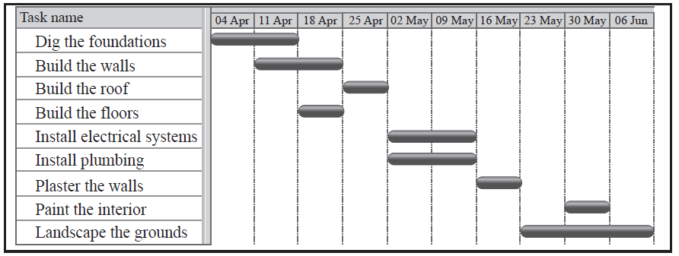Señor Rodriguez is having a new house built and will require local tradesmen to complete  
    a number of tasks.  
      
    The Gantt chart below shows the tasks involved in the building of the house.
14. Define the term concurrent processing. [1]
15. Identify **two** tasks that are carried out concurrently. [1]
16. Identify **two** tasks that are carried out sequentially. [1]
17. Describe how the idea of abstraction applies to one of the tasks. [2]
18. Explain **one** advantage and **one** disadvantage of carrying out a number  
    of tasks concurrently. [4]

Amalia Rodriguez, his daughter, is a student and is completing her homework.   
 This requires her to view web pages, edit a document, and print out draft copies.

However, she is also surfing the web, keeping up to date on her social networking  
 site as well as downloading apps and music from a P2P site.

1. For one of the application programs which she uses to perform these activities,  
   outline one task that is carried out by the application program itself. [2]

Within the application the graphical user interface (GUI) elements are reliant on the   
 operating system.

1. Identify two GUI components that are common to all of the above and are carried  
   out by the operating system. [2]
2. Outline how the use of abstract GUI components simplifies application programming. [2]
3. The operating system in the latest mobile phones allows the user to open more than   
   one application at the same time.
4. State **three** possible applications that might be open at the same time. [1]
5. Explain the role of the operating system in the management of these applications. [4]

The intended uses of a mobile phone influence its design with regard to system resources.

1. With reference to two specific resources, outline how the design of these resources  
   for a mobile phone would differ from those of a standard PC. [4]

A mobile phone manufacturer is considering adding a graphics card to one of   
 its models.

1. Discuss the possible consequences of going ahead with this modification. [6]
2. A company uses computer controlled equipment to monitor and control a heating system. The user controls the system via an on/off switch and two dials that are used to set the maximum and minimum temperatures desired.

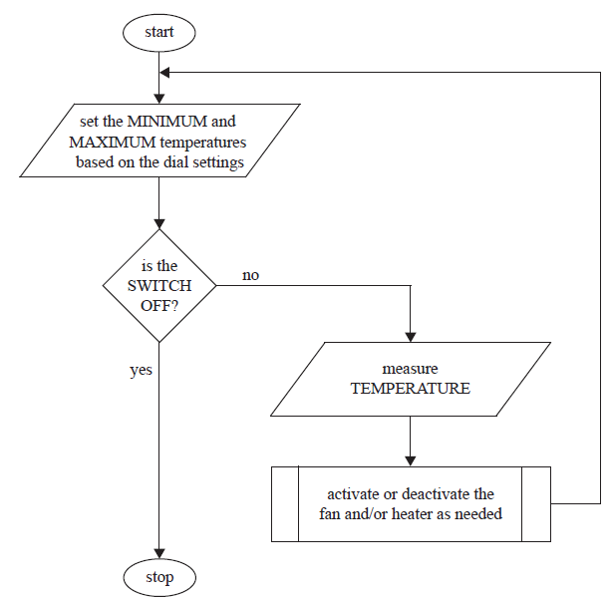The following flowchart represents the algorithm used to control temperature.

The temperature is constantly measured and the process of making the decision on   
which action to take is as follows.

If it is too cold (temperature is less than the minimum) then the heater should be  
switched on. If it is too hot (temperature is greater than the maximum) then the   
fan should be switched on. If temperature is within the given range (temperature  
greater than the minimum and less than the maximum) then both the fan and heater  
should be switched off.

1. Identify **one** situation in which the system should respond to
2. input from a user; [1]
3. temperature. [1]
4. State three hardware devices that are needed to capture the input data and   
   produce the system outputs. [3]
5. Construct pseudocode for the algorithm outlined on the previous page. [4]
6. The company wants to use its heating system to control the temperature of ten   
   different places at the same time. All ten places will have the same maximum and  
   minimum temperatures and each will have its own heater, fan, and temperature  
   sensor. Evaluate the decision of having all ten temperature sensors, fans, and heaters  
   connected to a single control computer instead of having ten separate heating systems. [6]